JUDUL (MAKSIMAL 20 KATA)

Nama Penulis 1
Nama Penulis 2

¹Identitas Institusi, Provinsi, Negara
Email: xxxxxx@xxx
²Identitas Institusi, Provinsi, Negara
Email: xxxxxx@xxx

ABSTRACT

text text text text text text text text text text text text text text text text text text text text text text text text text text text text text text text text text text text text text text text text text text text text text text text text text text text text text text text text text text text text text text text text text text text text text text text text text text text text text text text text text text text text text text text text text text text text text text text text text text text text text text text text text text text text text text text text text text text text text text text text text text text text text text text text text text text text text text text text text text text text text text text text text text text text text text text text text text text text text text text text text

Keywords: text; text; text.

ABSTRAK

text text text text text text text text text text text text text text text text text text text text text text text text text text text text text text text text text text text text text text text text text text text text text text text text text text text text text text text text text text text text text text text text text text text text text text text text text text text text text text text text text text text text text text text text text text text text text text text text text text text text text text text text text text text text text text text text text text text text text text text text text text text text text text text text text text text text text text text text text text text text text text text text text text text text text text text text text text text text text text text text text

Kata kunci: text; text; text.

PENDAHULUAN
text text text text text text text text text text text text text text text text text text text text text text text text text text text text text text text text text text text text text text text text text text text text text text text text text text text text text text text text text text text text text text text text text text text text text text text text text text text text text text text text text text text text text text text text text text text text text text text text text text text text text text text text text text text text text text text text text text text text text text text text text text text text text text text text text text text text text text text text text text text text text text

METODE PENELITIAN
text text text text text text text text text text text text text text text text text text text text text text text text text text text text text text text text text text text text text text text text text text text text text text text text text text text text text text text text text text text text text text text text text text text text text text text text text text text text text text text text text text text text text text text text text text text text text text text text text text text text text text text text text text text text text text text text text text text text text text text text text text text text text text text text text text text text text text text text text text text text text text

HASIL DAN PEMBAHASAN
text text text text text text text text text text text text text text text text text text text text text text text text text text text text text text text text text text text text text text text text text text text text text text text text text text text text text text text text text text text text text text text text text text text text text text text text text text text text text text text text text text text text text text text text text text text text text text text text text text text text text text text text text text text text text text text text text text text text text text text text text text text text text text text text text text text text text text text text text text text text text text

Tabel 1.
Analisis Data

Nomor | Informan | Keterangan
1. | Bapak Hamid | Kepala desa
2. | Ibu Siti | Sekretaris desa
3. | Bapak Robi | Camat
Sumber: dijelaskan, tahun

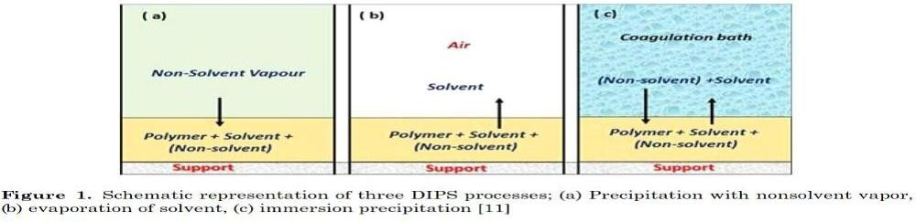
Sumber: dijelaskan, tahun
Gambar 1.
Judul Gambar

text text text text text text text text text text text text text text text text text text text text text text text text text text text text text text text text text text text text text text text text text text text text text text text text text text text text text text text text text text text text text text text text text text text text text text text text text text text text text text text text text text text text text text text text text text text text text text text text text text text text text text text text text text text text text text text text text text text text text text text text text text text text text text text text text text text text text text text text text text text text text text

PENUTUP
SIMPULAN
text text text text text text text text text text text text text text text text text text text text text text text text text text text text text text text text text text text text text text text text text text text text text text text text text text text text text text text text text text text text text text text text text text text text text text text text text text text text text text text text text text text text text text text text text text text text text text text text text text text text text text text text text text text text text text text text text text text text text text text text text text text text text text text text text text text text text text text text text text text text text text
SARAN
text text text text text text text text text text text text text text text text text text text text text text text text text text text text text text text text text text text text text text text text text text text text text text text text text text text text text text text text text text text text text text text text text text text text text text text text text text text text text text text text text text text text text text text text text text text text text text text text text text text text text text text text text text text text text text text text text text text text text text text text text text text text text text text text text text text text text text text text text text text text text text

REFERENSI
Chabrak, N., & Craig, R. (2013). Student Imaginings, Cognitive Dissonance and Critical Thinking. Critical Perspectives on Accounting, 24(2), 91–104.
https://doi.org/10.1016/j.cpa.2011.07.008
Kusdewanti, A. I., Setiawan, A. R., Kamayanti, A., & Mulawarman, A. D. (2014). Akuntansi Bantengan: Perlawanan Akuntansi Indonesia Melalui Metafora Bantengan dan Topeng Malang. Jurnal Akuntansi Multiparadigma, 5(1), 149–169.
Mulawarman, A. D. (2007). Melampaui Pilihan Keberpihakan: Pada UMKM atau Ekonomi Rakyat. In Seminar Regional Tinjauan Kritis Rancangan Undang-Undang tentang Usaha Mikro, Kecil, dan Menengah.
Triyuwono, I. (2003). Kearifan Lokal: Internalisasi “Sang Lain” dalam Dekonstruksi Pengukuran Kinerja Manajemen. In I. Triyuwono & A. E. Yustika (Eds.), Emansipasi Nilai Lokal Ekonomi dan Bisnis Pascasentralisasi Pembangunan (pp. 155–173). Malang: Bayumedia.
Triyuwono, I. (2012). Akuntansi Syariah: Perspektif, Metodologi dan Teori (2nd ed.). Jakarta: Rajawali Pers.

